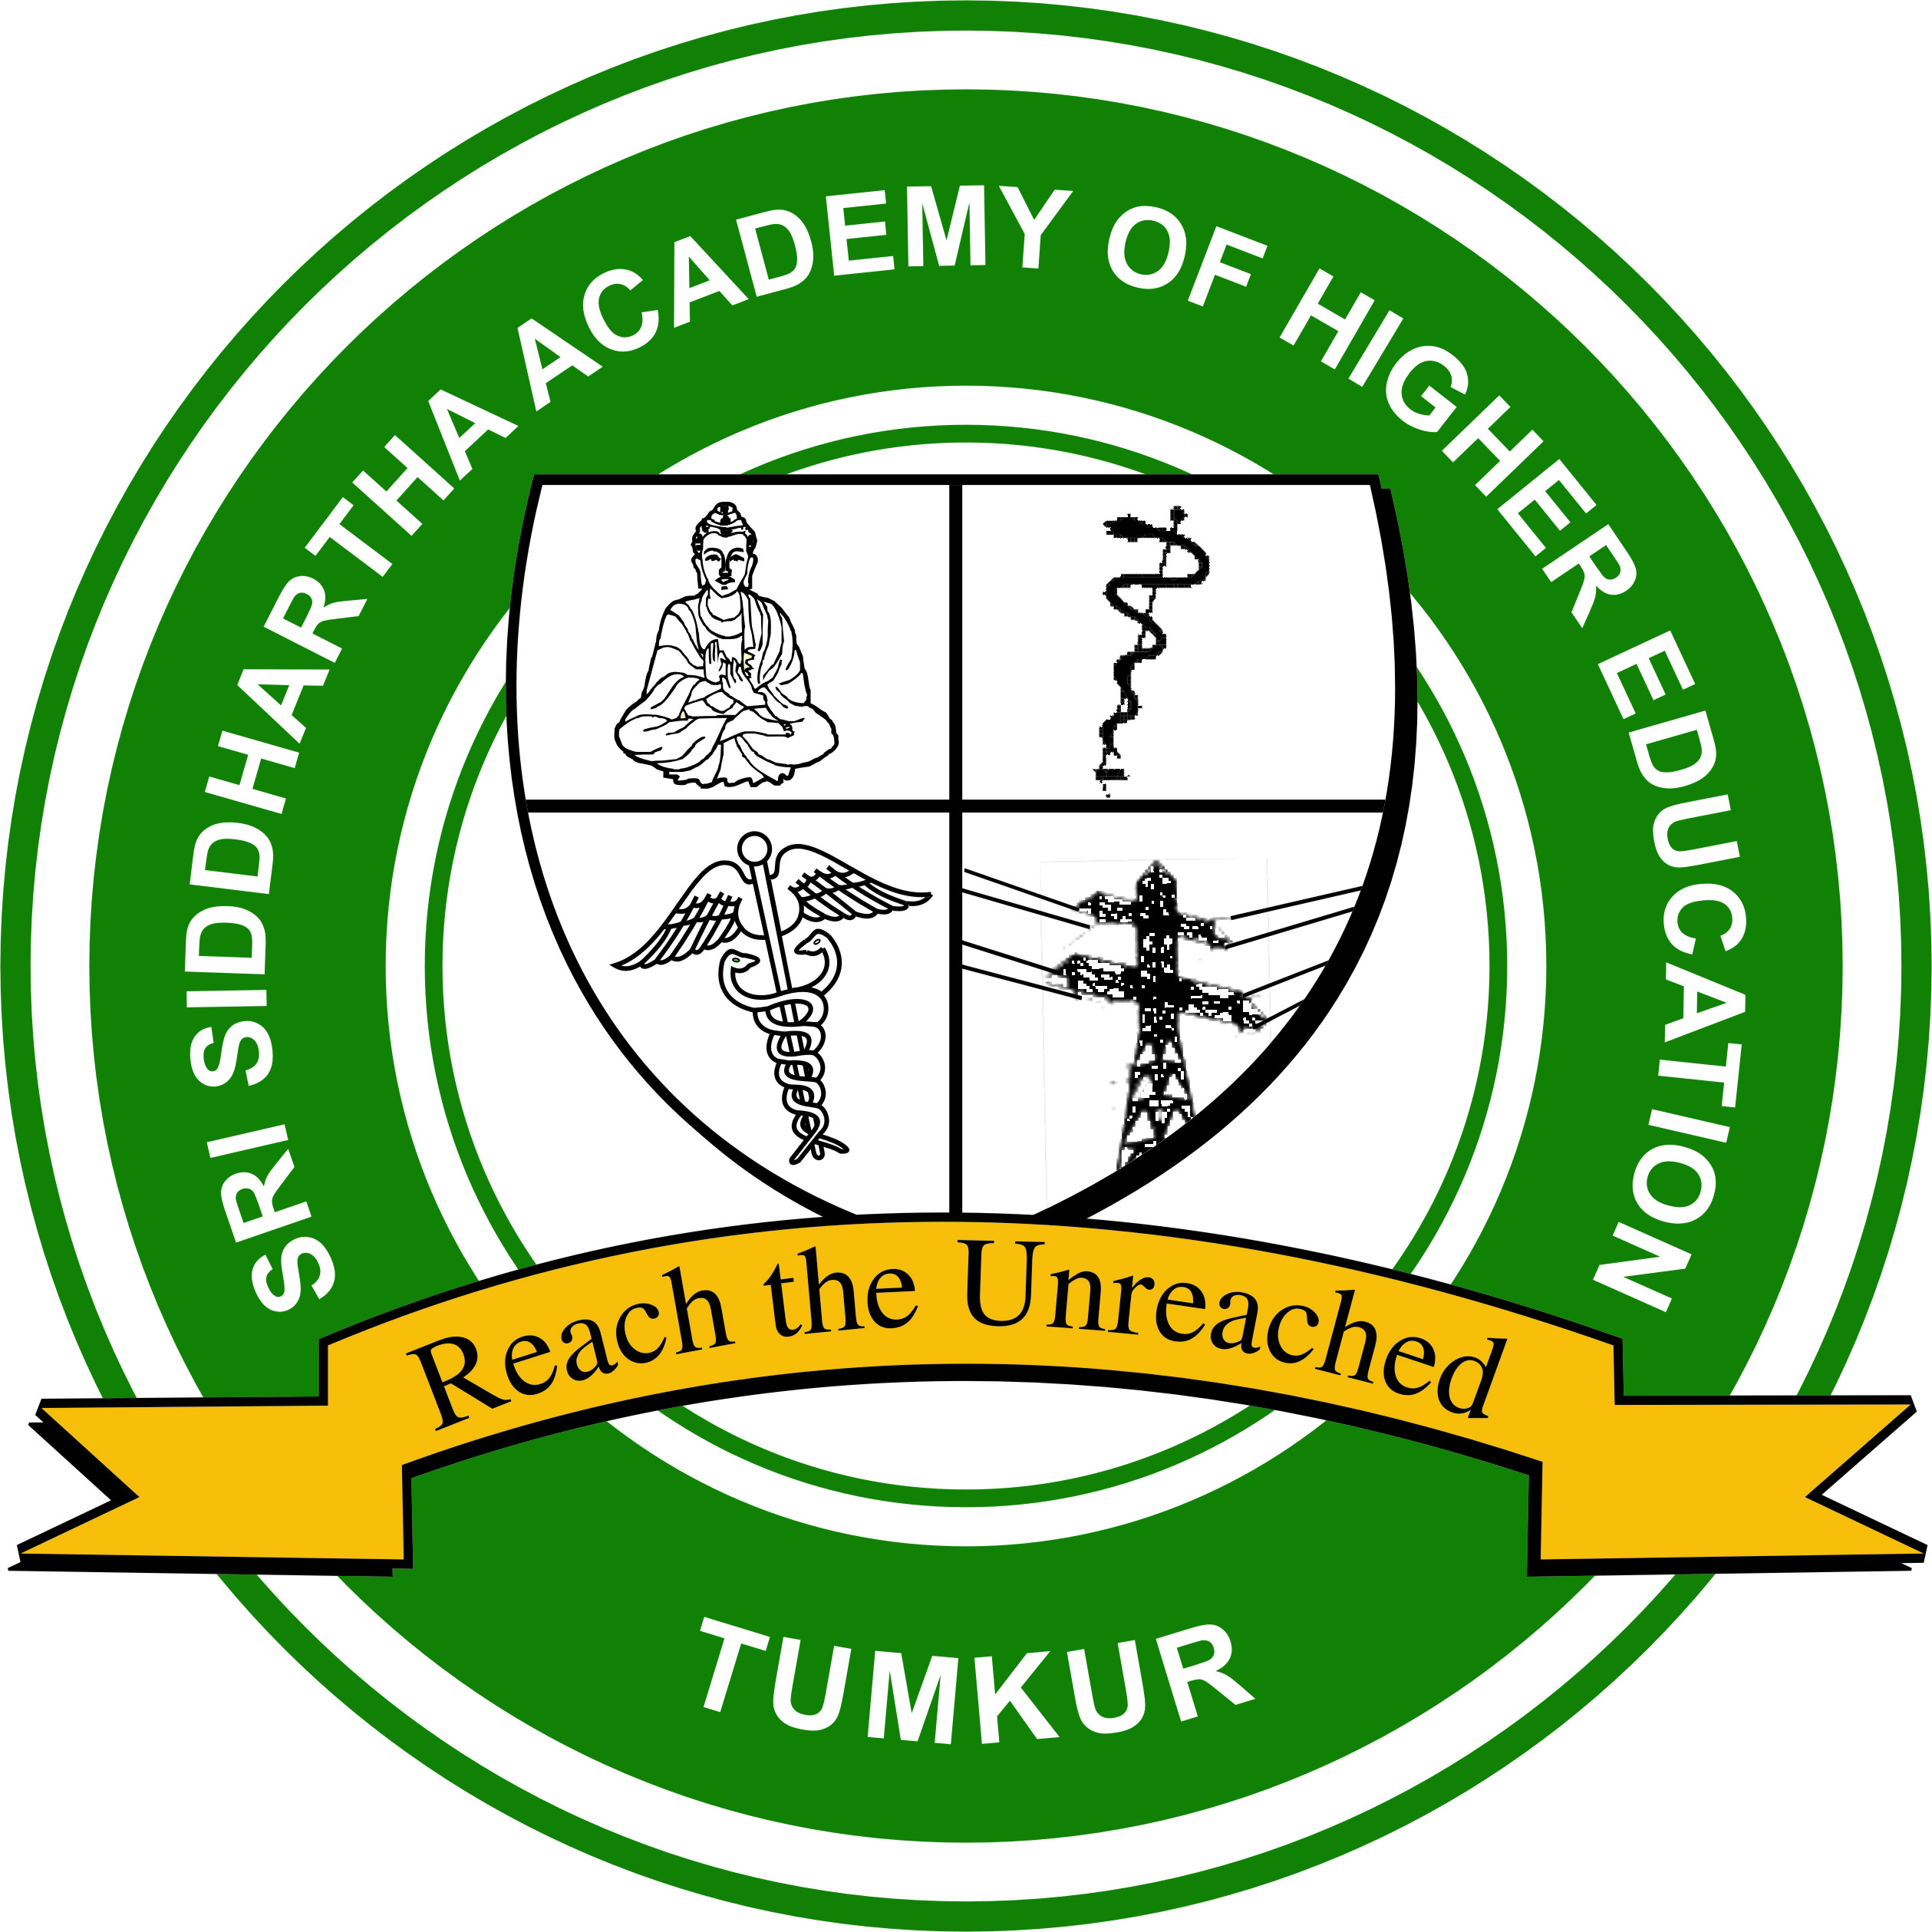
SRI SIDDHARTHA ACADEMY OF HIGHER EDUCATION
(DEEMED TO BE UNIVERSITY)
Declared under Section 3 of the UGC Act, 1956, MHRD GOI No. F.9-31/2006-U.3 (A) dated: 30/05/2008
Accredited ‘A’ Grade by NAAC
Agalakote, B.H.Road, Tumkur – 572 107.KARNATAKA, INDIA.
Ph. 0816- 2275516, 2275512 , Fax : 0816-2275510 website: sahetumkur.ac.in email: info@sahe.in , iqac@sahe.in

1.1.3 Provide a description of courses having focus on competency/employability/ entrepreneurship/ skill-development offered either by the University or in collaboration with partner Institutions / Industries during the last five years
Response:
The Mission of the university is achieved through the constituent colleges to promote optimal health for the community through many outreach programs, which constitutes core of its curriculum designed to promote community based training. Based on prevalence of disease data which is made available through rural and urban health centers, community health check up camps are organized by the college.
With a constant change in the pattern of disease there are new innovations which will be trained to both medical and dental students at UG and PG levels in the form of workshops and CME/CDE. Regular interdepartmental meetings train them for better approach to patient care. In addition students are posted to KIDWAI and NIMHANS for the speciality training. Community postings at RHTC and UHTC help them to acquire special skills like house to house survey, rapport building and real life experiences in rural setup.
The exposure to various skills training with state-of-art technology and exposure with the enormous patients make them ready for employment. Problem based learning, field studies/ visits, case based studies, surveys, rural / industrial visits, hands on experience and project works ensure skill development in relevant subject of study. The university and college encourage the faculty to take up new research projects helping them upgrade themselves. Furthermore, students are encouraged to undertake research under faculty guidance, and present in conferences and publish. Well equipped skill lab assists them in gaining the confidence to treat the patients. Advanced and basic life support training for interns are provided.
The Employability of the graduates and postgraduates of all programs is considered during the curriculum framing and for achieving this, the departments include additional skills, value added courses and enrichment programs, along with early clinical and industry exposure. Comprehensive medical and dental care training is included to help students learn and cater to the complete treatment needs of patients. Camps in both rural and urban areas are conducted to reach the needs of the local population. The alumni of these institutions are practicing medicine and dentistry in different parts of the country and worldwide imparting service to the community at large either independently or employed.
Each institution has sufficient number of MoU with industries and institutions to enrich students’ knowledge and skills by conducting workshops, training, technical talks, seminars, etc.
The courses offered by the engineering college provide professional skills and technical competencies through the curriculum design which bridge the gap between Industry and Academia
Communication skills and Professional Ethics
Pre-assessment Test and Introduction to Aptitude
Vedic mathematics
Number systems
Puzzles: General Puzzle, Coding and Decoding, Number Series, Alpha-Numeric Puzzle, Blood relation, Brain Teasers, Directions
Arithmetic: Percentage, Ratio and Proportion, Averages, Compound and Simple Interest, Partnership, Profit loss and Discount, Time and work, Mixture and Allegation, Time speed and Distance, Pipe and Cisterns, Clock and Calendar
Algebra: Equations (Linear and Quadratic) , Age Problems, Direction problems, Progression.
Modern Math’s: Permutation, Combination, Probability, Set Theory
Geometry
Reasoning: Logical Reasoning, Deductive Reasoning, Mathematical Reasoning, Relationship Reasoning
Data Analysis
Visual Sequence
Post Assessment Test
Pre-Placement activities

MEDICAL /DENTAL | Date | Event title | No. of students attended
Competency/employability/entrepreneurship/skill development course
2017-18 | 17/04/2018 | Giving Precision incision Skill development of students on phantom head models | 20
2017-18 | 18/5/2017 | Ethics in biomedical research | 30
2017-18 | 8/8/2017 | Headpiece sterilization and maintenance : A training programme for undergraduates | 40
2017-18 | 03/05/2017 | Forensic odontology- competency course | 30
2017-18 | 03/03/2017 | Comprehensive Implantology hands on course | 6
2017-18 | 16/09/2017 | Training for Dental chair functioning | 25
2017-18 | 20/08/2018- 21/08/2018 | Temporomandibular joint dysfunction and management  - T scan and Tense therapy | 16
2017-18 | 24/1/18 | taking OPG | 13
2017-18 | 08/08/2017 | Hands on workshop for headgear, facemask and other orthopaedic appliance for postgraduate students. | 06
2018-19 | 16/07/2019 | Skill development of local drug delivery gels incorporating curcumin | 06
2018-19 | 25/5/2018 | Research methodology | 30
2018-19 | 20/7/2018 | Sculpting the Cearmics :A laboratory training programme for the fabrication of ceramic restorations | 20
2018-19 | 18/04/2018 | Microscopy-skill development course | 35
2018-19 | 16/01/2018 | Jain hospital, Bangalore | 4
2018-19 | 19/07/2018 | Training for parenteral administration in pediatric patients | 06
2018-19 | 18/07/2019- 20/07/2019 | Occlusion in prosthodontics | 18
2018-19 | 25/10/18 | examination of lymphadenopathy | 9
2018-19 | 13/09/2018 | Program for bonding techniques in orthodontics for interns. | 10
2019-20 | 24/03/2020 | Skill development of students on sharpening of surgical instruments | 20
2019-20 | 11/1/2019 | Tobacco cessation and counselling | 35
2019-20 | 12/3/2020 | Customized wire and loop technique for retrieval of broken instruments | 20
2019-20 | 17/07/2019 | Genetics - PCR & its application –skill development course | 30
2019-20 | 10/06/2019 | HCG Institute of cancer care, Bangalore | 4
2019-20 | 24/08/2019 | Training for the management of LA complications in children | 06
2019-20 | 5/06/2020-  6/06/2020 | Geriatric nutrition and counseling | 20
 | 29/7/19 | bitewing radiography | 12
 | 10/12/2019 | Program for loop mechanics for PG’s | 06

MEDICAL /DENTAL | Date | Event title | No. of students attended
Competency/employability/entrepreneurship/skill development course
2020-21 | 08/02/2021 | Immunohistochemistry –competency course | 06
2020-21 | 13/1/2021 | Communication skill among health care personnels | 30
2020-21 | 10/5/2021 | Magnification with Dental operating microscope : A training programme for undergraduate students | 50
2020-21 | 20/01/2020 | Special stains- skill development course | 06
2020-21 | 14/09/2020 | Oncology, KIDWAI Memorial institute of Oncology, Bangalore | 4
2020-21 | 08/12/2020 | Rotary endodontics in paediatric patients | 7
2020-21 | 27/2/2021 | Pharmacovigilance as a career opportunity for dental graduates | 40
2020-21 | 9/11/2020 | NSK hand piece maintenance | 28
2020-21 | 25/2/2021 | National oral pathologist day | 30
2020-21 | 16/7/2021 | Manufacturing local drug delivery gels incorporating cur cumin | 6
2020-21 | 24/3/2021 | Sharpening of surgical instruments | 20
2020-21 | 16/11/2020 | Die and die system made easy | 12
2021-22 | 4/2/2022 | Designing questionnaire | 35
2021-22 | 5/4/22 | NSK hand piece maintenance | 26
2021-22 | 15/3/2022 | MPDS & Restorative dentistry :A clinical skill training programme for Temporamandibular joint disorders | 20
2021-22 | 15/10/2021 | Essix retainer as orthodontic retainer | 5
2021-22 | 16/8/2021 | Traumatology, NIMHANS, Bangalore | 4
2021-22 | 12/09/2021 | Basic life support | 30
2021-22 | 9/10/2021 | Magnification LOUPES | 35
2021-22 | 25/4/2022 | Soft tissue calcification and ossification in OPG – diagnostic consideration | 14
2021-22 | 24/5/2022 | Sedate 101 | 27
2021-22 | 31/5/2022 | Know about tobacco cessation | 30
2021-22 | 29/9/2021 | Age estimation by cemental annulations | 18
2021-22 | 25/2/2022 | National oral pathologist day | 30
2021-22 | 15/3/2022 | Micrometry morphometry | 10
2021-22 | 5/6/2022 | Implant as orthodontic anchorage | 4
2021-22 | 15/7/2022 | Oncology, KIDWAI Memorial institute of Oncology, Bangalore | 4
2021-22 | 8/10/2021 | Untangle esthetics # edelweiss way | 19

